ADTA 5560: Recurrent Neural Networks for Sequence Data
Thuan L Nguyen, PhD

Final Project

PART I: A Time-series Data Set (10 Points)
SUBMISSION REQUIREMENT #1:

--) Write a report on the dataset that includes (but not limited to) all the critical information of the dataset, e.g., name, data type, an official website where to get the data, links to download, the timeseries span (how long the time span is), the data (how many data points), the data structure of the data contained in the dataset, and so on.
--) If possible (data: numeric or categorical), submit the data set as a .CSV file.
Answer:
Introduction: I downloaded a timeseries dataset which contains the time series analysis of wintertime O3 and NOx formation. The details of the dataset are specified below.
- Name: Olson Utah Time Series
- Data Type: Time Series
- Source: https://catalog.data.gov/dataset/time-series-analysis-of-wintertime-o3-and-nox-formation
- Timeseries Span: Hourly Data
  - Start time: 29-01-2017 00:00:00
  - End time: 02-02-2017 23:00:00
- Data Points: 120 rows
- Data Structure:
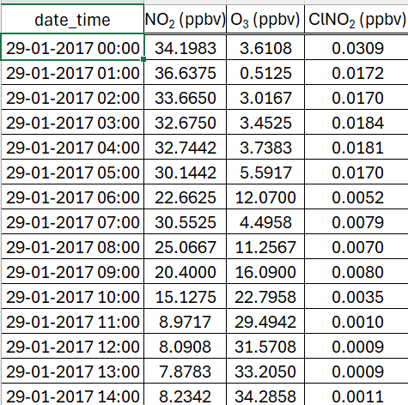

- Data:
  - date_time: Categorical
  - NO₂ (ppbv): Numerical
  - O₃ (ppbv): Numerical
  - ClNO₂ (ppbv): Numerical
Conclusion: We discussed the details of the dataset to understand and have a snapshot the data.
PART II: RNN: Simple RNN with Sine Wave Data (10 Points)
--) Add one section to discuss the design of the neural network into the MS Word document,
“ADTA_5560_final_project.docx,” including the diagram of the neural network.

--) Add another section to report the results of training and evaluating the model into the document:
“ADTA_5560_final_project.docx.”

--) Submit all the code and the results of running the code in a Jupyter Notebook document (*.ipynb)

Answer:
Design of the Simple Neural Network:
Dataset:
- The dataset has only one feature: sine value of index x
- Input feature: Only one feature is used for training (n_features = 1)
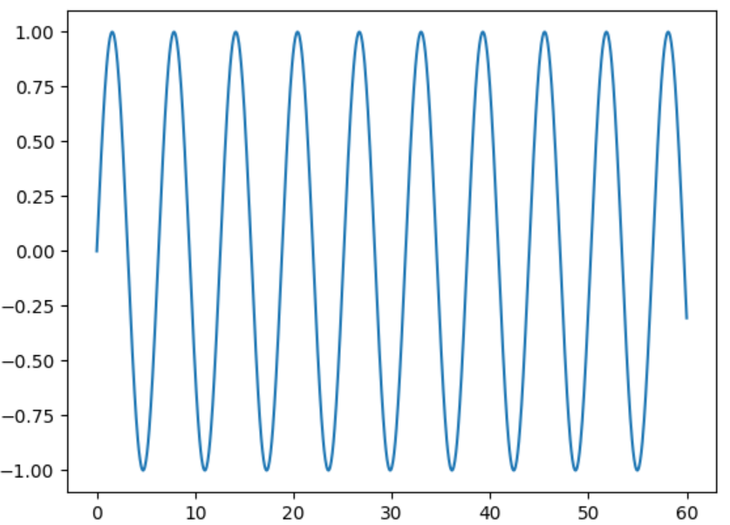

Model Architecture:
- Sequential Model: The model is defined as a sequential model.
- Simple RNN layer:
  - Number of neurons: 100
  - Input Shape: (length, n_features), length is the number of time steps in the sequence.
  - Processes sequential information while keeping the temporal dependencies between inputs.
- Fully Connected (Dense) Layer:
  - Number of Neuron: 1 neuron
  - It works as the output layer to predict the next value in the sequence based on the input.

Diagram of the Simple Neural Network:
Diagram: The below diagram shows the neural network with two layers with simple RNN and a fully connected layer.
Note: for the sake of simplicity, the number of neurons is reduced in the diagram, there should be 100 neurons as per the design of the network.

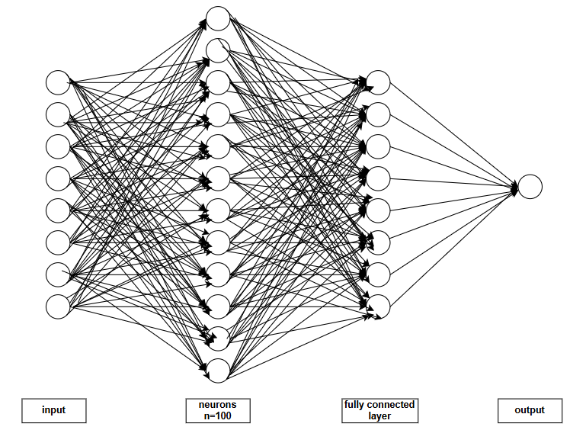
Figure: Diagram of the Simple Neural Network

Model Training and Evaluation:
- Compiling the Model:
  - Use model.compile to compile the model.
- Train (Fit) the Model:
  - Fit the model using model.fit()/ model.fit_generator()
  - The loss value of 1.5065e-04 shows that the model can predict the values quite well.

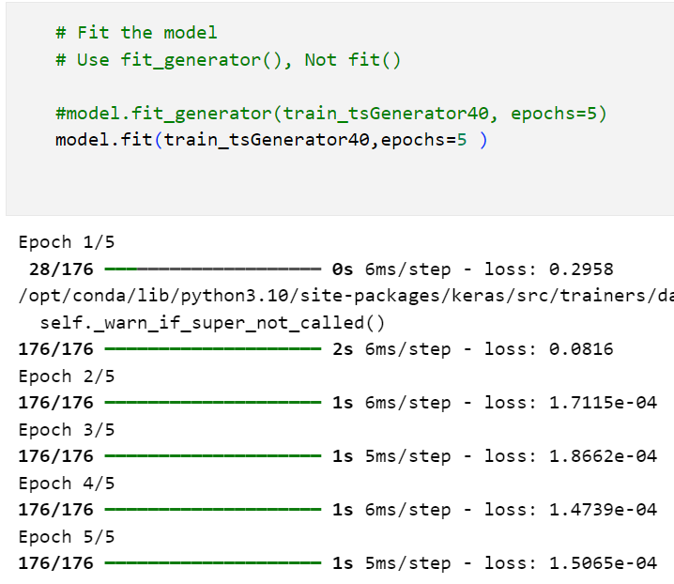
- Visualize model performance after training:
  - The loss data is loaded into a dataframe and ploted.
  - The figure below displays the plot.
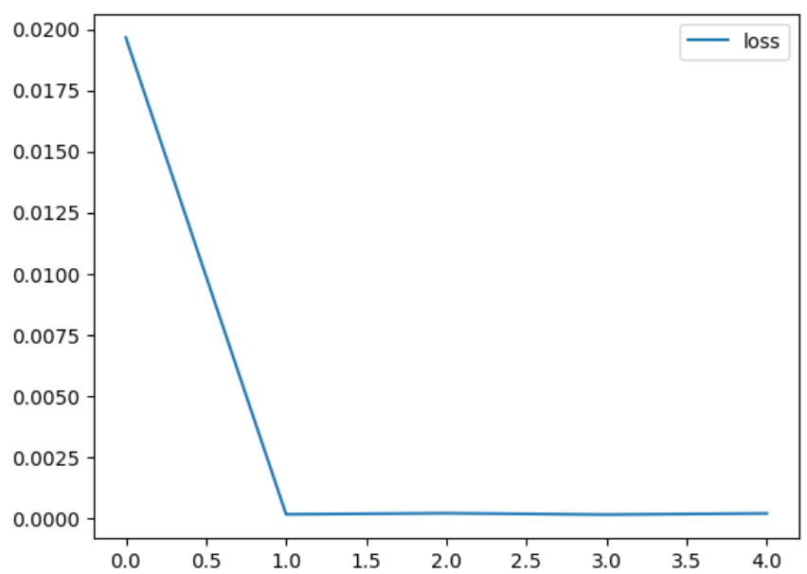
Figure: plot of loss function data
- Evaluation of the Model’s performance on Tests Data
  - Stored the predictions in a separate list
  - Made predictions for each batch and append it in the list.
- Append the predictions list to the dataframe
  - Visualized the predicted sine wave and the original sine wave.
  - From the below plot we can state that the model is able to predict the values quite well.
  - The below figure shows the same.
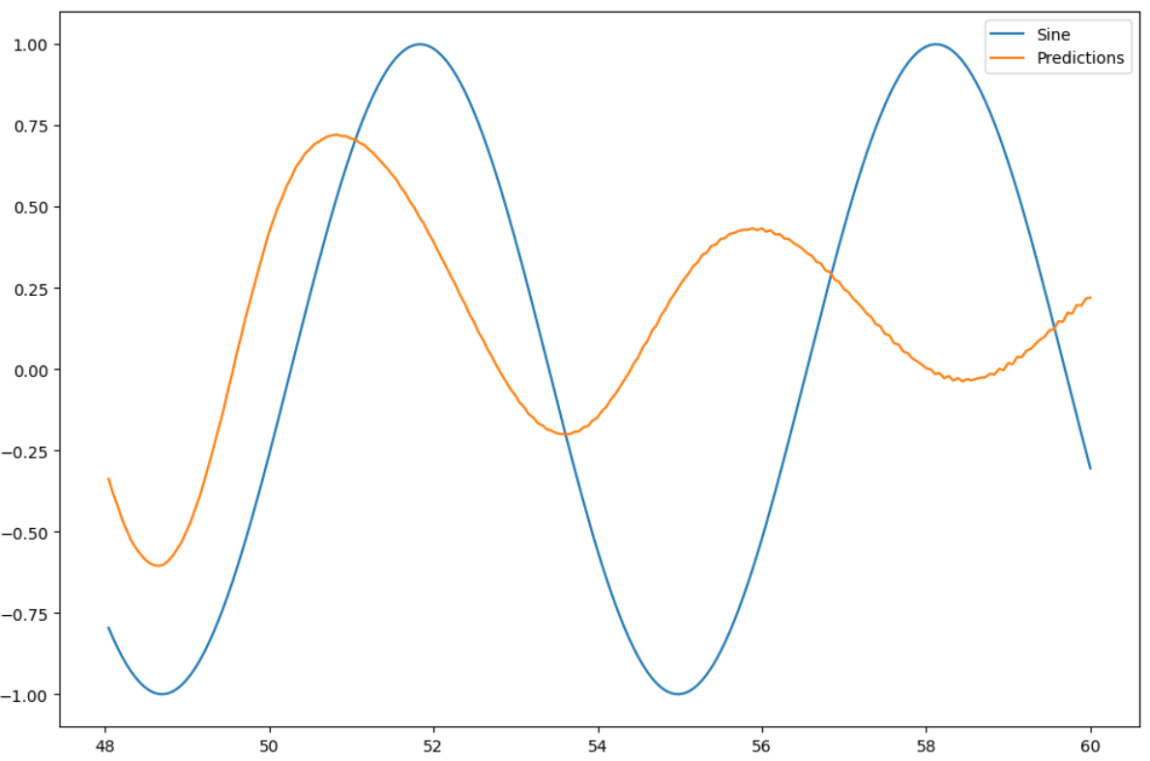
Figure: Plot of predicted value and original sine wave values
PART III: RNN: LSTM Neural Network (20 Points)

SUBMISSION REQUIREMENT #3

Question 3.1:
--) Explain the vanishing gradient problem
Answer:
Vanishing Gradient Problem:
- During back propagation, recurrent neural networks suffer from the vanishing gradient problem.
- Gradients are values used to update weights that are applied to a neural network.
- A gradient measures how much the output of a function changes if you change the inputs a little bit.
The vanishing gradient problem:
- When the gradient shrinks as it back propagates through time.
- If a gradient value becomes extremely small, it stops contributing to the network’s learning.
- In other words, the neural network stops learning.
- Layers that get a very small gradient update stops learning.
- Those are usually the earlier layers and these layers don’t learn.
- RNN’s can forget what it has seen in the earlier time steps of long sequences, thus having a shortterm memory due to the problem of vanishing gradient.
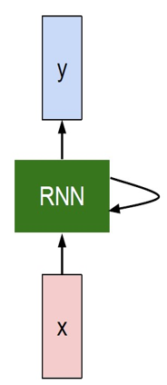
Updated Weight = Weight – Learning Rate * Gradient
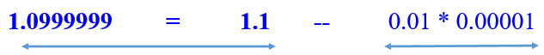
- In the above example we can see that the weight is barely updated.
- During back propagation, recurrent neural networks suffer from the vanishing gradient problem.

--) Explain the exploding gradient problem
Answer:
Exploding Gradient Problem:
- Exploding gradient problem is contrary to Vanishing Gradient problem.
- It occurs when the gradient becomes too large during the backpropagation.
- In this case the weights become too large and the network starts to diverge.
- This causes difficulty for the model to learn the underlying pattern in the data.
- This is often the result of gradients greater than 1, leading to a rapid increase in values as you propagate them backward through the layers.
- Mathematical representation of the Exploding Gradient Problem
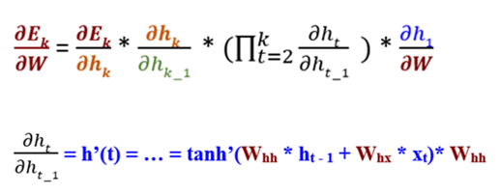
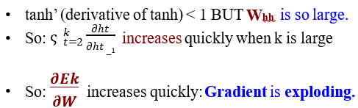

Question 3.2:
--) Discuss the limitations of the SimpleRNN neural network
Answer:
Simple Recurrent Neural Network are designed to efficiently process the sequential data. However, there are some limitations with the Simple RNN which include.
- Short Term Memory:
  - The hidden state of the memory gets updated in each step so the previous information in no longer retained.
  - If a sequence is long, it’s hard for RNN’s to “memorize” the information at earlier time steps.
  - The loss function outputs an error value that estimates the network performance.
  - Last, it uses the generated error value to perform back propagation.

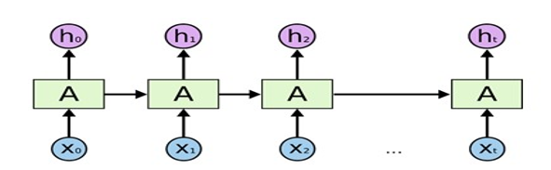
Figure: Unrolled RNN
- Vanishing Gradient Problem:
  - The vanishing gradient problem is a common phenomenon which occurs when the gradient becomes very small during backpropagation as the weights of the network do not change significantly.
  - With this the model loses its ability to learn from the data significantly.
- Exploding Gradient Problem:
  - The exploding gradient problem is a common phenomenon which occurs when the gradient becomes very big during backpropagation as the weights of the network change significantly.
  - With this the model loses its ability to learn from the data significantly as it causes severe divergence.

Question 3.3:
--) Explain how the LSTM neural network can provide powerful solutions to both gradient problems (Vanishing and Exploding) and address the limitations of the SimpleRNN neural network.
Answer:
LSTM (Long Short Term Memory) neural network is considered as a powerful solution to the Vanishing and exploding gradient problem of the simple neural network.
Introduction:
In the mid-90s, Sepp Hochreiter and Juergen Schmidhuber (German researchers) proposed the Long-Short-Term Memory (LSTM) neural network as a solution to the vanishing gradient problem.
Details:
- The LSTM network can preserve the gradient along the path of backpropagation through time and layers.
- It maintains a more constant gradient while backpropagation is done.
- The neural network can continue learning over many time steps.
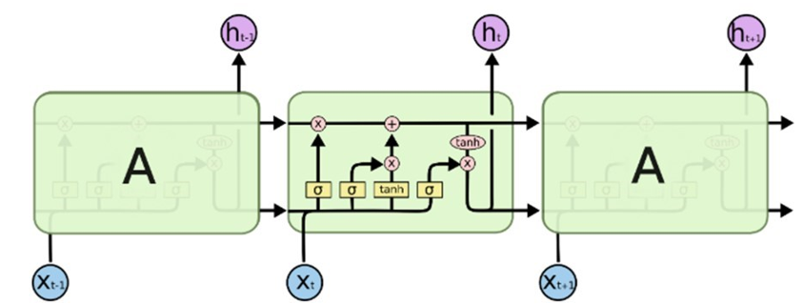
Figure: Unrolled LSTM neural network
- An LSTM cell has C state, or Cell state, in addition to H state, or Hidden state.
- LSTM Cell State:
  - Can to transfer information from the earliest time steps all the way to the end of the sequence chain.
  - It can carry relevant information throughout the processing of the sequence.
  - Can mitigate the problem of short-term memory.
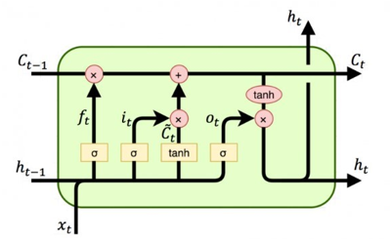
Figure: LSTM Cell
- LSTM Gates:
  - LSTM cell uses the gates to regulate the flow of information moving along the path of processing the sequence chain.
  - There are three gates: Forget, Input, and Output in an LSTM Cell, each with one sigmoid activation function.
  - Each gate is a neural network that can learn to determine what information should be relevant or significant and then be used.
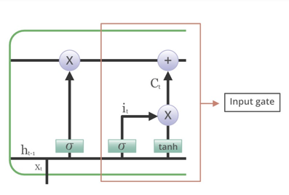
Figure: LSTM gates
  - Each gate can learn to decide, during the training on what information to keep because it is relevant and which information to “forget” because it is irrelevant or insignificant.
Conclusion:
The cell state of the LSTM we ensure the movement of the information across the cell and with the gates we ensure the decision of keep and forget for the information. Hence, LSTM can address the limitations of a simple recurrent neural network.

PART IV: RNN: LSTM with Time-Series Data (20 Points)

SUBMISSION REQUIREMENT #4

--) Add one section to the MS Word document, “ADTA_5560_final_project.docx,” to discuss the neural network design, including the neural network diagram.

--) Add one section with the title “Summary of Core Parameters” that lists all crucial relevant parameters and their values (number of LSTM layers, number of neurons per LSTM layer, number of DropOut layer, length of the input sequence, batch size, etc.)

--) Add another section into the document: “ADTA_5560_final_project.docx,” to report the results of all these above steps (build, train, test, retrain, and forecast)

--) Submit all the code and the results of running the code in a Jupyter Notebook document (*.ipynb)

Answer:
Objective:
- To Build an LSTM neural network using the Keras sequential model
- Train the model using the training data, which is part of the collected data set.
- Test the model using the testing data allocated from the collected data set.
- Retrain the model using the entire collected data set and prepare it for forecasting.
- Perform the forecasting using the retrained model.
- Run all the project steps in a Jupyter Notebook document to get the results of each step.
Design of the neural network:
The model is designed according to the complexity of the dataset so that it can efficiently predict/forecast the required datapoints.
The sequential model consists of:
- Percentage of data for testing: 10%
- Three LSTM layers
- Two dropout layers
- One fully connected layers
- The below screenshot shows the model build in the Virtual Machine.
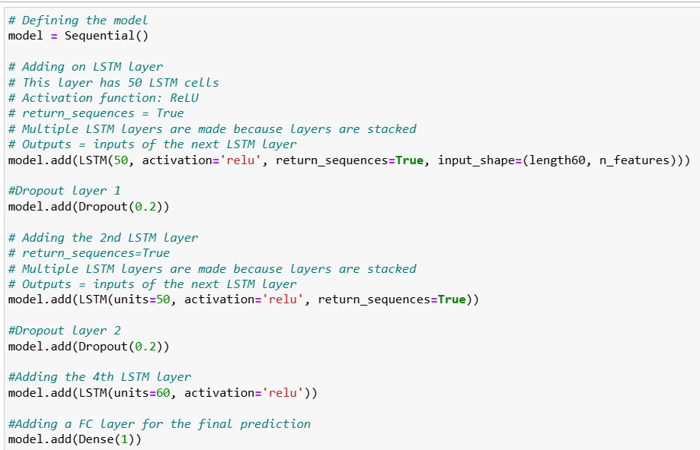
- Model Summary:
  - The below diagram shows summary of the model.
  - Total params: 57,301 (223.83 KB)
  - Trainable params: 57,301 (223.83 KB)
  - Non-trainable params: 0 (0.00 B)
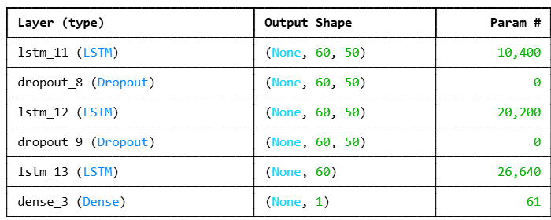

Preprocessing:
- To improve the model’s efficiency, the data is normalized using the MinMaxScaler from sklearn.preprocessing to scale the Close prices between 0 and 1.
- I split the data into training and testing sets, with 90% of the data for training and 10% for testing.
- The sequences are created with 60-time steps sliding window.

Summary of Core Parameters:
- crucial relevant parameters and their values:
  - number of LSTM layers:
    - Three stacked LSTM layers
    - Activation function: ReLU
    - To enable stacking, the return_sequences=True parameter was used
  - number of neurons per LSTM layer: 50 neurons each
  - number of DropOut layer:
    - two dropout layers, once after each LSTM layer.
    - Dropout regularization is set to 20% to reduce overfitting.
  - length of the input sequence: 60
  - batch size: 32
  - Number of epochs: 100

Results:
- Build
  - The sequential model is built with one input feature three LSTM layers.
  - Two of them have return sequences.
  - There are two dropout layers.
- Train
  - The model is trained with Time series generator and 100 epochs.
  - The below screenshot shows the training of the model.
  - The loss value for training the model is 0.0025
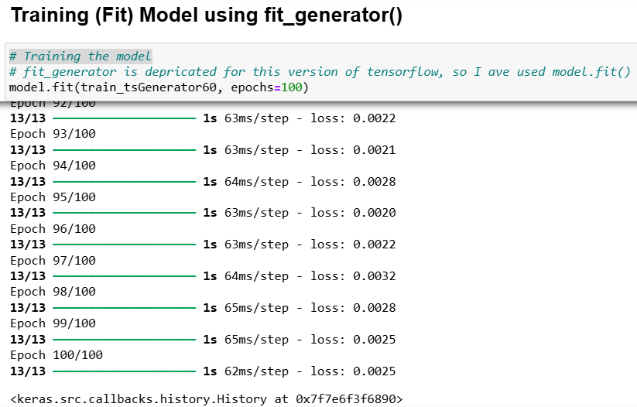
  - The below screenshot shows the plot for loss (MSE).
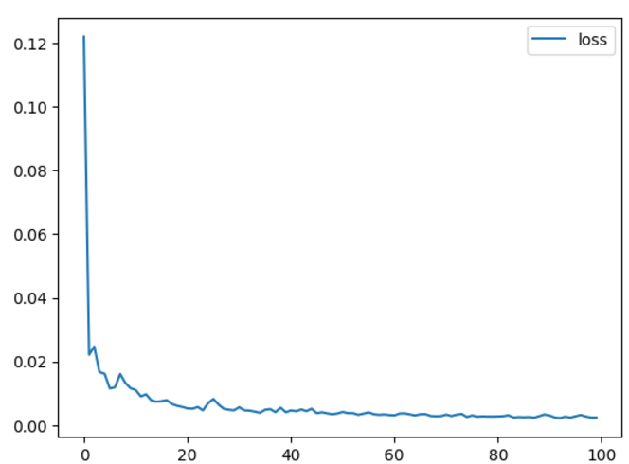

- Test
  - The model is tested on the test dataset which is normalized.
- Retrain
  - The model is retrained on the full dataset.
- Forecast
  - The data is forecasted for 107 days.
  - The below screenshot shows the forecasted data.
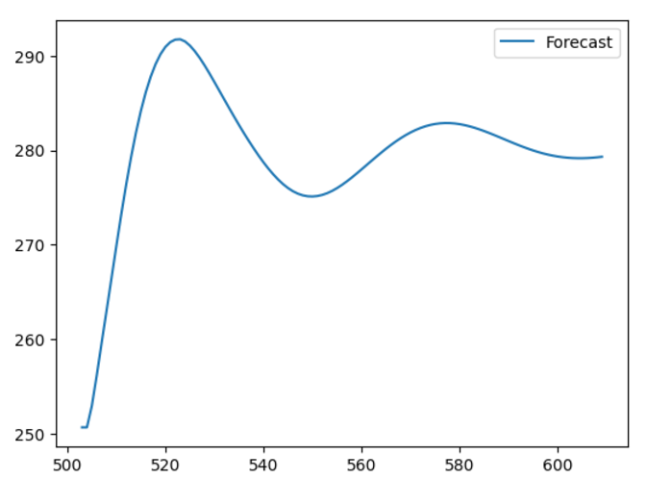
Figure: Plot for Forecast
  - The loss value for training the Forecasting data is 0.0017
  - The below screenshot shows the same.
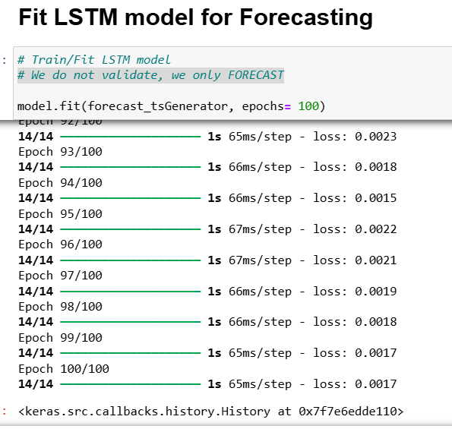
Figure: Screenshot for training the Forecasting data
  - The plot for the actual values is shown below.
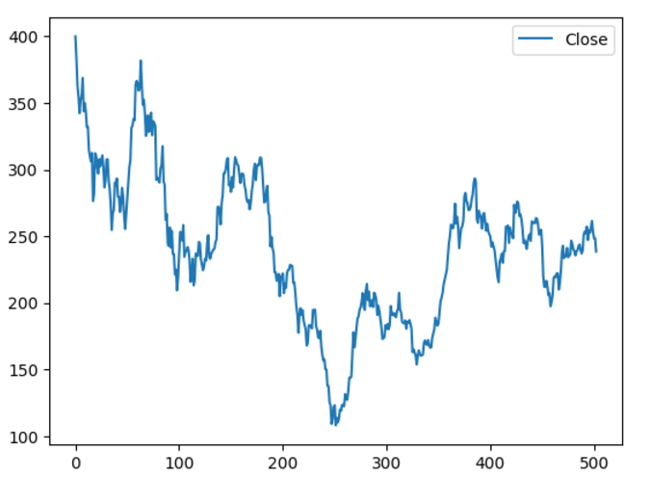
Figure: Plot for Actual Data

- Actual and Forecasted data:
  - The below plot shows the actual and forecasted data.
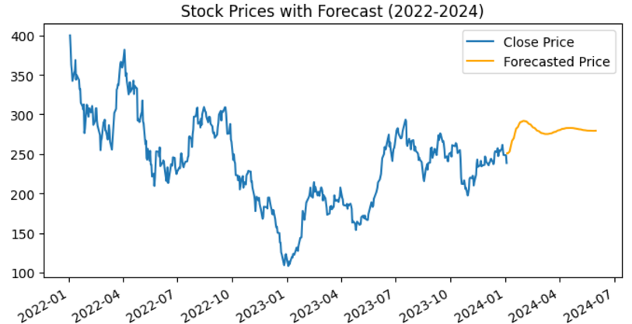
Figure: Actual and Forecasted data

PART V: Redesign the Neural Network (10 Points)
SUBMISSION REQUIREMENTS #5:

--) Add one section into the MS Word document, “ADTA_5560_final_project.docx,” to discuss the new neural network design, including the redesigned neural network diagram..

--) Add one section with the title “Summary of Updated Core Parameters” that lists all crucial relevant parameters and their values (number of LSTM layers, number of neurons per LSTM layer, number of DropOut layer, length of the input sequence, batch size, etc.) applied to the redesigned network.

--) Add another section into the document: “ADTA_5560_final_project.docx,” to report the results of all these above steps (build, train, test, retrain, and forecast).

--) Submit all the code and the results of running the code in a separate Jupyter Notebook (*.ipynb)

Answer:

Business Proposal to make changes to improve the performance:
We propose to add an additional LSTM layer and a dropout layer to improve the performance of the existing model for the same dataset.
With these changes made the redesigned model consists of the below listed components.
- Three LSTM layers with return sequences.
- Three dropout layers with 20% dropout rate.
- One LSTM layer without any return sequences.
- One dense layer
We anticipate having an improved performance with the redesigned model.
Design of the neural network:
The model is re-designed to improve the efficiency of the model so that it can predict/forecast the required datapoints with higher accuracy.
The sequential model consists of:
- Percentage of data for testing: 10%
- Four LSTM layers (three with return sequences and one without any return sequence).
- Three dropout layers
- One fully connected layer
- The below screenshot shows the model build in the Virtual Machine.
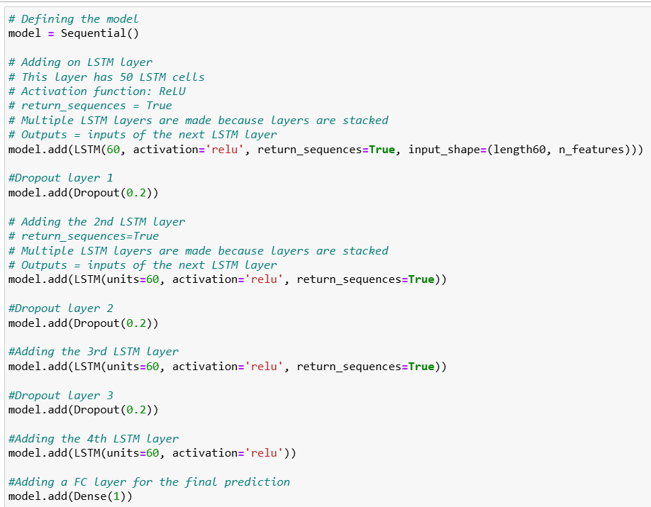
- Model Summary:
  - The below diagram shows summary of the model.
  - Total params: 102,061 (398.68 KB)
  - Trainable params: 102,061 (398.68 KB)
  - Non-trainable params: 0 (0.00 B)
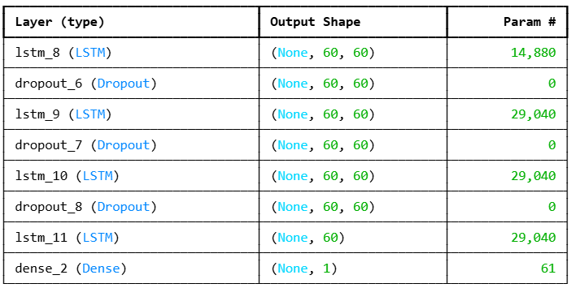

Preprocessing:
- To improve the model’s efficiency, the data is normalized using the MinMaxScaler from sklearn.preprocessing to scale the Close prices between 0 and 1.
- I split the data into training and testing sets, with 90% of the data for training and 10% for testing.
- The sequences are created with 60-time steps sliding window.
Summary of Updated Core Parameters:
- crucial relevant parameters and their values:
  - number of LSTM layers:
    - Four stacked LSTM layers
    - Activation function: ReLU
    - To enable stacking, the return_sequences=True parameter was used
  - number of neurons per LSTM layer: 60 neurons each
  - number of DropOut layer:
    - Three dropout layers, once after each LSTM layer.
    - Dropout regularization is set to 20% to reduce overfitting.
  - Length of the input sequence: 60
  - Batch size: 32
  - Number of epochs: 100
Results:
- Build
  - The sequential model is built with one input feature four LSTM layers.
  - Three of them have return sequences.
  - Three are two dropout layers.
- Train
  - The model is trained with Time series generator and 100 epochs.
  - The loss value for training the model is 0.0032
  - The below screenshot shows the training of the model.

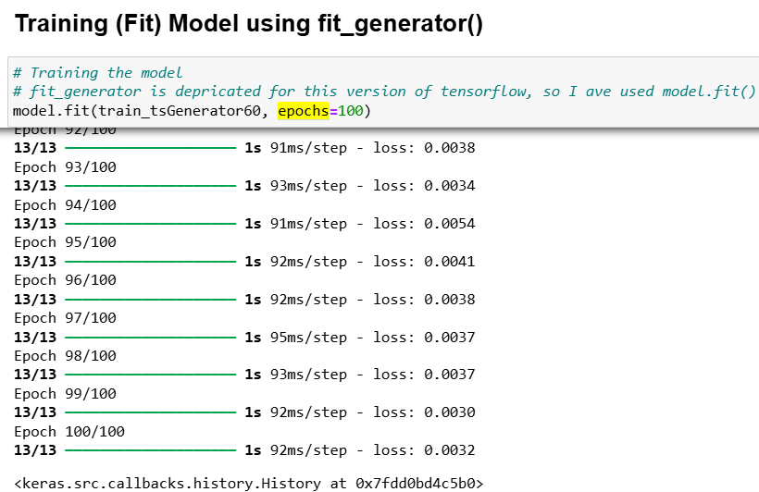
  - The below screenshot shows the plot for loss (MSE).
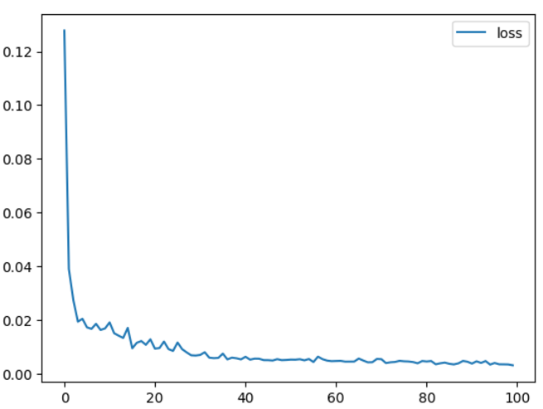

- Test
  - The model is tested on the test dataset which is normalized.
- Retrain
  - The model is retrained on the full dataset.
- Forecast
  - The data is forecasted for 107 days.
  - The below screenshot shows the forecasted data.
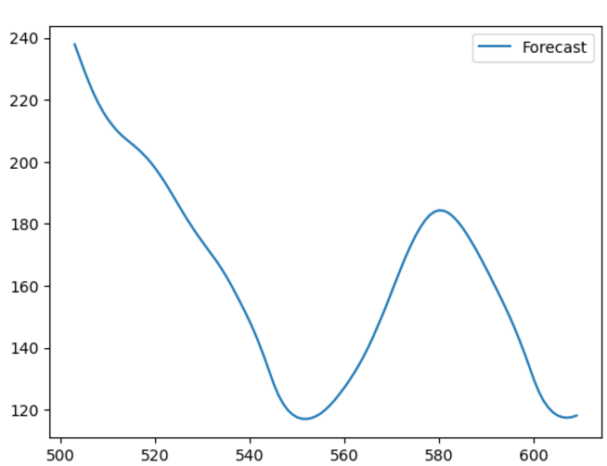
Figure: Plot for Forecast
  - The loss value for training the Forecasting data is 0.0027
  - The below screenshot shows the same.
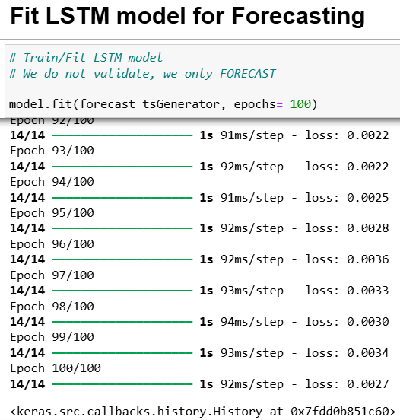
Figure: Screenshot for training the Forecasting data
  - The plot for the actual values is shown below.
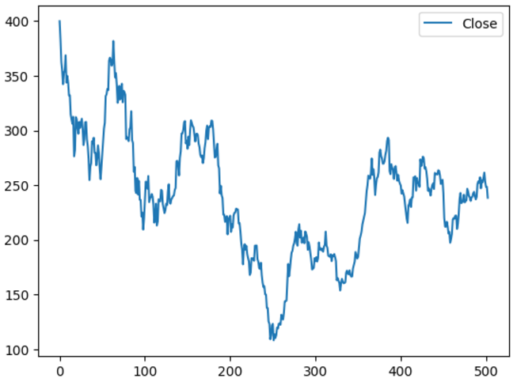
Figure: Plot for Actual Data

- Actual and Forecasted data:
  - The below plot shows the actual and forecasted data.
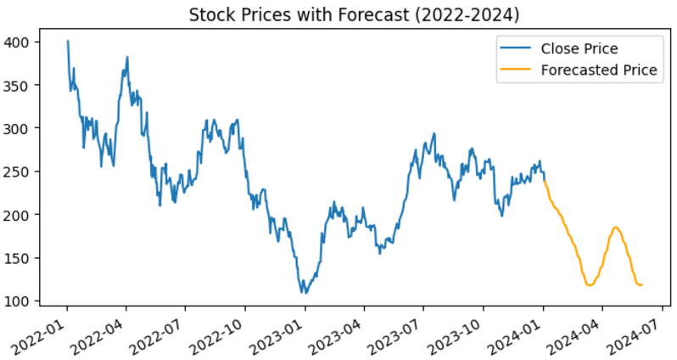
Figure: Actual and Forecasted data

PART VI: Compare Network Performance (10 Points)
SUBMISSION REQUIREMENTS #6:

--) Add one new section into the MS Word document, “ADTA_5560_final_project.docx,” for the above report.
Answer:
Objective:
To compare and analyse the difference in the performance of the two recurrent neural networks build with different design on the same dataset.
Introduction: As part of section IV, we have designed a neural network for time series data with LSTM (Long Short Term Memory). As part of section V, we have redesigned the neural network to improve the performance of the model. In this section, we will discuss about the performance and results of each model.
Comparison:
The below table shows the Core Parameters and Design Components of both the models.
Component | Model: Part IV | Model: Part V
Percentage of data for testing | 10% | 10%
Layers of LSTM | Three | Four
Number of Neuron in each LSTM | 50 | 60
Dropout Layers | 2 | 3
Percentage of drop | 20% | 20%
Length of time series input sequence | 60 | 60
Batch size | 32 | 32
Number of epochs | 100 | 100
Loss value for training the model | 0.0025 | 0.0032
Loss value for training the Forecasting data | 0.0017 | 0.0027

The difference are highlighted in yellow.
Explanation:
Design/Core Components:
- Part IV has three LSTM layers with 50 neurons each and two dropout layers. It is a simple design.
- Part V has four LSTM layers with 60 neurons each and three dropout layers. It is a comparatively complex design then part IV.
Training Loss:
- Part IV has a better training performance with the loss value of 0.0025.
- Part V has a slightly higher loss value of 0.0032 due to the increased complexity of the model.
Forecasting Loss:
- Part IV has lower value of 0.0017, indicating a better generalizing on for the forecasting data.
- Part V has slightly higher value of 0.0027 and indicates the need for further enhancement/ tuning of the model.
Conclusion:
There is no significant difference between the performance of both the models. However, the model in part IV has slightly better performance than the redesigned model in part V.
PART VII: Project Report (20 Points)

SUBMISSION REQUIREMENTS #7:

The student must submit the following additional sections to the report:
(1) Write an introduction section to introduce the project
(2) Describe what the student has done in PART II, III, IV, and V in the final project
(3) List what the student has learned from the models (Simple RNN and LSTM) and what he/she has experienced while working with them (build, train, test, and forecast)
(4) Write a conclusion section to conclude the project report.

Answer:
Project Report
Objective:
To discuss the various parts of the project, learning from the models and experience while working with the models.
Introduction:
This is the final project for the course ADTA5560: Recurrent Neural Network. As as part of this project we have performed the below listed activities.
- Part I: Time Series data set - Searched a time series data set and wrote a report on the same.
- Part II: RNN: Simple RNN with Sine Wave Data – Built a simple RNN with sine wave data.
- PART III: RNN: LSTM Neural Network – Discussed about vanishing gradient, exploding gradient, limitations of simple RNN, benefits of LSTM
- PART IV: RNN: LSTM with Time-Series Data – Built an LSTM with Time-Series data.
- PART V: Redesign the Neural Network – Redesigned the LSTM model to achieve better performance.
- Part VI: Compare Network Performance – Compared the design and core components of both the models in part IV and part V.
Description:
We will be focusing on Part II, III, IV, V in this section.
Part II: RNN: Simple RNN with Sine Wave Data –
In this section we designed a simple RNN. The data was generated from a sign wave (no external data was used).
Input Feature: sine value of index x.
We split the training (80%) and testing data (20%).
Scaled the training data and normalized it.
Created the time series generator with the input sequence length of 40.
Model: Sequential model with one input feature, a simple RNN layer with 100 neurons and a dense layer which serves as an output layer.
The model is compiled and trained with 5 epochs.
The loss function is plotted to understand the learning rate of the model.
The model is evaluated, true predictions are generated with inverse transformation.
True predictions are added to the actual dataset and plotted.
The loss function value is very small for this model hence, this model has a higher accuracy for predictions.
Learning and Experience: In this section we learned about the simple recurrent neural network, how it can be built, trained and evaluated.
Part III: RNN: LSTM Neural Network –
In this section, we discussed about the limitations of RNN and how these limitations can be solved by LSTM.
- Short Term Memory: Simple RNN have a short term memory and it can not retain the information for a long sequence data.
- Vanishing Gradient Problem:
  - The vanishing gradient problem is a common phenomenon which occurs when the gradient becomes very small during backpropagation as the weights of the network do not change significantly.
  - With this the model loses its ability to learn from the data significantly.
- Exploding Gradient Problem:
  - The exploding gradient problem is a common phenomenon which occurs when the gradient becomes very big during backpropagation as the weights of the network change significantly.
  - With this the model loses its ability to learn from the data significantly as it causes severe divergence.

LSTM:
- LSTM Cell State:
  - Can transfer information from the earliest time steps all the way to the end of the sequence chain.
  - It can carry relevant information throughout the processing of the sequence.
  - Can mitigate the problem of short-term memory.

Figure: LSTM Cell
- LSTM Gates:
  - LSTM cell uses the gates to regulate the flow of information moving along the path of processing the sequence chain.
  - There are three gates: Forget, Input, and Output in an LSTM Cell, each with one sigmoid activation function.
  - Each gate is a neural network that can learn to determine what information should be relevant or significant and then be used.

Figure: LSTM gates
  - Each gate can learn to decide, during the training on what information to keep because it is relevant and which information to “forget” because it is irrelevant or insignificant.
Learning and Experience: Here we learnt about the limitations of simple RNN which are short term memory, vanishing gradient and exploding gradient. LSTM is a powerful solution to these issues as it can propagate the information through its cell state and make decisions with the Gates.
PART IV: RNN: LSTM with Time-Series Data –
In this section we have built an LSTM with Time-Series data.
We have split the data into training (90%) and testing (10%).
Length of input sequence: 60
Normalized the data and created time series generator with a batch size of 32.
Model:
- number of LSTM layers:
  - Three stacked LSTM layers
  - Activation function: ReLU
  - To enable stacking, the return_sequences=True parameter was used
- number of neurons per LSTM layer: 50 neurons each
- number of DropOut layer:
  - two dropout layers, once after each LSTM layer.
  - Dropout regularization is set to 20% to reduce overfitting.
- length of the input sequence: 60
- batch size: 32
- Number of epochs: 100
Train the model and predict the values.
Visualize the prediction.
Normalize the full dataset to train the forecasting.
Visualize the actual and the forecasted values.
Join the actual and the forecasted values and plot to visualize.
Learning and Experience: LSTM is a strong model to capture the temporal complexities of time series data and can effectively process long sequences unlike the Simple RNN.
PART V: Redesign the Neural Network —
In this section we have built an LSTM with Time-Series data.
We have split the data into training (90%) and testing (10%).
Length of input sequence: 60
Normalized the data and created time series generator with a batch size of 32.
Model:
- number of LSTM layers:
  - Four stacked LSTM layers
  - Activation function: ReLU
  - To enable stacking, the return_sequences=True parameter was used
- number of neurons per LSTM layer: 60 neurons each
- number of DropOut layer:
  - Two dropout layers, once after each LSTM layer.
  - Dropout regularization is set to 20% to reduce overfitting.
- length of the input sequence: 60
- batch size: 32
- Number of epochs: 100
Train the model and predict the values.
Visualize the prediction.
Normalize the full dataset to train the forecasting.
Visualize the actual and the forecasted values.
Join the actual and the forecasted values and plot to visualize.
Learning and Experience: The redesigned LSTM model has an additional LSTM layer and dropout layer which makes this model more complex than the model built in part IV. This model does not have any significant difference in the performance. Hence, we can state that, complex model does not necessarily bring better performance.
Conclusion:
In conclusion, we can state that the project presented a comprehensive understanding of Recurrent Neural Networks, the drawbacks of RNN, Long Short Term Memory (LSTM) and how LSTM can overcome the issues with RNN with the Cell State and Gates. We also understood how these models can be implemented in time series data modelling. We identified that adding complexity to the model does not necessarily improve the performance when we compared the models in part IV and part V.
Insights:
The insights that we learned is the significance of balancing a model to achieve optimal performance.
PART VIII: Final Presentation Videos: YouTube Links
Answer:
The video presentation is split into three short videos of approximately 10 minutes each.
Please find the youtube video links below
https://youtu.be/vnPB3K48PUY
https://youtu.be/RzyHsdwk7f4
https://youtu.be/FPv2wwLmxow

Note: The below Jupyter notebooks are submitted along with the project report.
ADTA_5560_Final_Project_Part_IV_LSTM with TimeSeries Data
ADTA_5560_Final_Project_Part_V_Redesign the Neural Network
ADTA5560_Final_Project_Part_II_Simple_RNN_With_Sine_Wave_Data

Reference:
https://www.superdatascience.com/blogs/recurrent-neural-networks-rnn-the-vanishing-gradient-problem
https://www.geeksforgeeks.org/gradient-descent-algorithm-and-its-variants/
https://www.geeksforgeeks.org/gradient-descent-algorithm-and-its-variants/#how-the-gradient-descent-algorithm-works
Understanding LSTM Networks -- colah's blog
https://towardsdatascience.com/illustrated-guide-to-lstms-and-gru-s-a-step-by-step-explanation-44e9eb85bf21
Course Material: ann_rnn_recurrent_neural_networks_LSTM_PART_I
Course Material: ann_rnn_recurrent_neural_networks_LSTM_PART_II
Course Material: ann_rnn_recurrent_neural_networks_LSTM_PART_III

